

MOI HIGH-KABARAK 2025 PREDICTION
Kenya Certificate of Secondary Education
KCSE PREDICTION SERIES 1
443/1 Agriculture Paper 1
Time: 2 Hours

NAME…………………………………………………………………………………………
SCHOOL……………………………………………… SIGN…………………………..
INDEX NO……………………………………………. ADM NO………………………

Kenya Certificate of Secondary Education.

INSTRUCTIONS TO STUDENTS
(a) Write your name and index number in the spaces provided at the top of this page.
(b) Sign and write the date of the examination in the spaces provided.
(c) This paper consists of three sections: A, B and C.
(d) Answer all questions in sections A and B.
(e) Answer any two questions in section C.
(f) All answers should be written in the spaces provided.

FOR EXAMINER’S USE ONLY
SECTION | QUESTIONS | MAXIMUM SCORE | CANDIDATES SCORE
A | 1 − 19 | 30
B | 20− 23 | 20
C |  | 20
 |  | 20
 | TOTAL SCORE | 90

SECTION A- (30 MARKS)
Answer all questions in the spaces provided
- State the three forms in which horticulture is practiced in Kenya (1¹/₂ marks)
………………………………………………………………………………………………………
………………………………………………………………………………………………………
………………………………………………………………………………………………………

- Identify two ways in which agriculture support agro based industries (1 mark)
………………………………………………………………………………………………………
………………………………………………………………………………………………………
………………………………………………………………………………………………………

- List down three biotic factors that influence agriculture negatively (1¹/₂marks)
………………………………………………………………………………………………………
………………………………………………………………………………………………………
………………………………………………………………………………………………………

- Name any three crops that can be propagated by use of suckers (1¹/₂marks)
………………………………………………………………………………………………………
………………………………………………………………………………………………………
………………………………………………………………………………………………………

- Outline four roles of trees in soil conservation (2 marks)
………………………………………………………………………………………………………
………………………………………………………………………………………………………
………………………………………………………………………………………………………
………………………………………………………………………………………………………

- Identify two examples of intensive farming systems practiced in crop production (1 mark)
………………………………………………………………………………………………………
………………………………………………………………………………………………………
- Outline four ways in which living organisms contribute to soil formation (2 marks)
………………………………………………………………………………………………………
………………………………………………………………………………………………………
………………………………………………………………………………………………………
………………………………………………………………………………………………………

- Give four reasons that may necessitate sub soiling to be carried out on a piece of land (2 mks)
………………………………………………………………………………………………………
………………………………………………………………………………………………………
………………………………………………………………………………………………………
………………………………………………………………………………………………………

- Name any four physical methods of water treatment (2 marks)
………………………………………………………………………………………………………
………………………………………………………………………………………………………
………………………………………………………………………………………………………
………………………………………………………………………………………………………

- Give three reasons why green manure is not commonly used (1¹/₂marks)
………………………………………………………………………………………………………
………………………………………………………………………………………………………
………………………………………………………………………………………………………

- Name two types of labour records that can be kept by a large scale plantation farmer.(1 mark)
………………………………………………………………………………………………………
………………………………………………………………………………………………………

- Outline four areas that should be avoided when collecting a soil sample for testing (2 marks)
………………………………………………………………………………………………………
………………………………………………………………………………………………………
………………………………………………………………………………………………………
………………………………………………………………………………………………………
- Differentiate between a seed bed and a seedling bed (1 mark)
………………………………………………………………………………………………………
………………………………………………………………………………………………………

- Name three field practices that are used to support weak stemmed crops (1¹/₂marks)
………………………………………………………………………………………………………
………………………………………………………………………………………………………
………………………………………………………………………………………………………

- Give four reasons that would make a farmer chose a jembe during land preparation over a disc plough (2 marks)
………………………………………………………………………………………………………
………………………………………………………………………………………………………
………………………………………………………………………………………………………
………………………………………………………………………………………………………

- Give a reason why use of organic manure is discouraged in carrot production (1 mark)
………………………………………………………………………………………………………
………………………………………………………………………………………………………

- Outline four advantages of zero grazing as a system of grazing (2marks)
………………………………………………………………………………………………………
………………………………………………………………………………………………………
………………………………………………………………………………………………………
………………………………………………………………………………………………………

- Identify four sources of credit facilities where one can get capital to carry out crop production
(2 marks)
………………………………………………………………………………………………………
………………………………………………………………………………………………………
………………………………………………………………………………………………………
………………………………………………………………………………………………………
- Name any three fertilizer elements (1¹/₂ marks)
………………………………………………………………………………………………………
………………………………………………………………………………………………………
………………………………………………………………………………………………………

SECTION B (20 MARKS)
Answer all questions in this section.
- The following are photographs of weeds obtained from the farm
A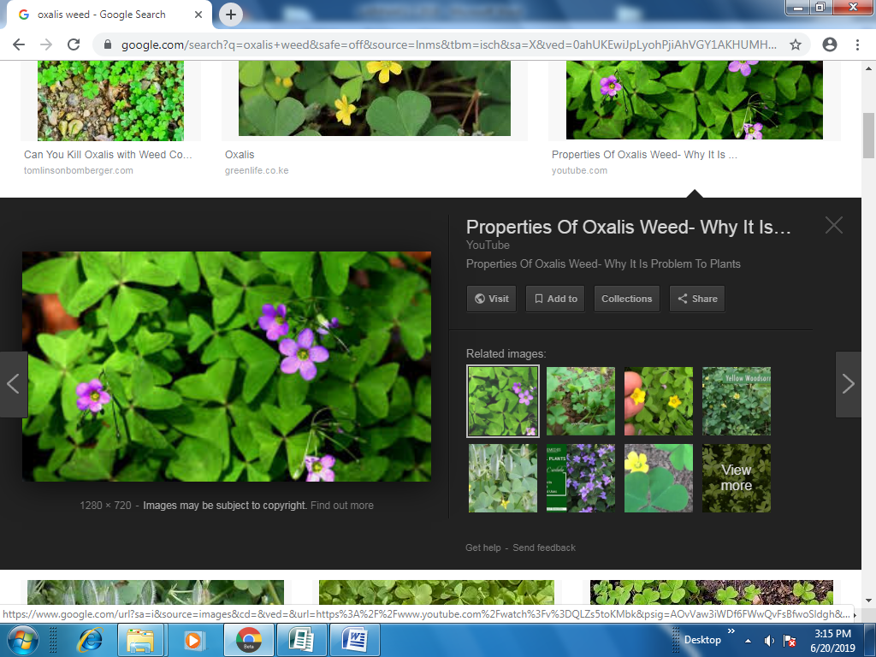 B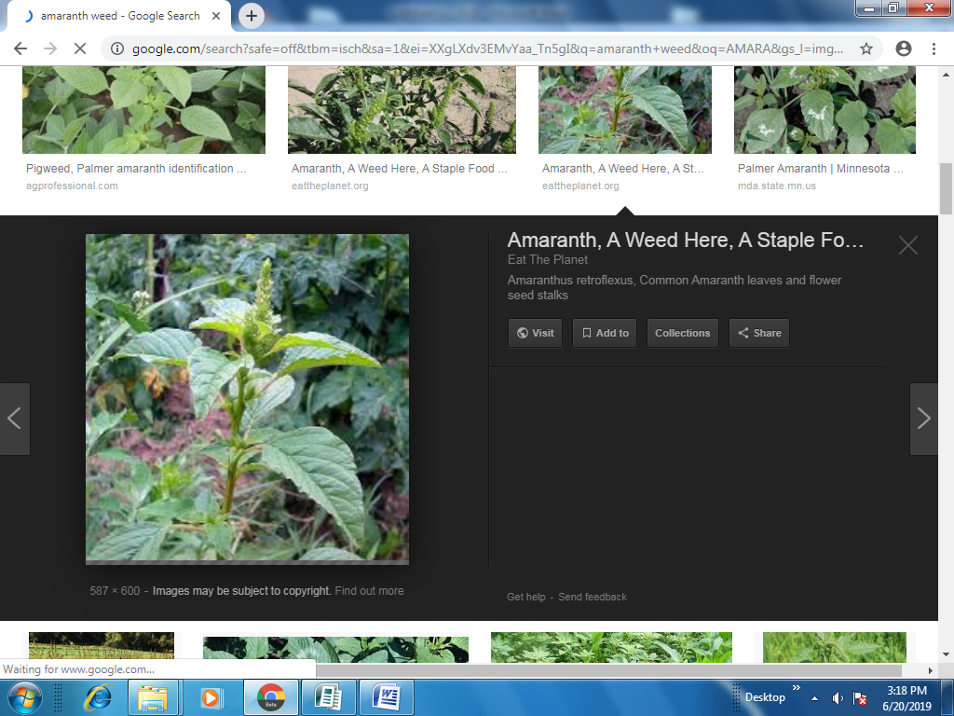
C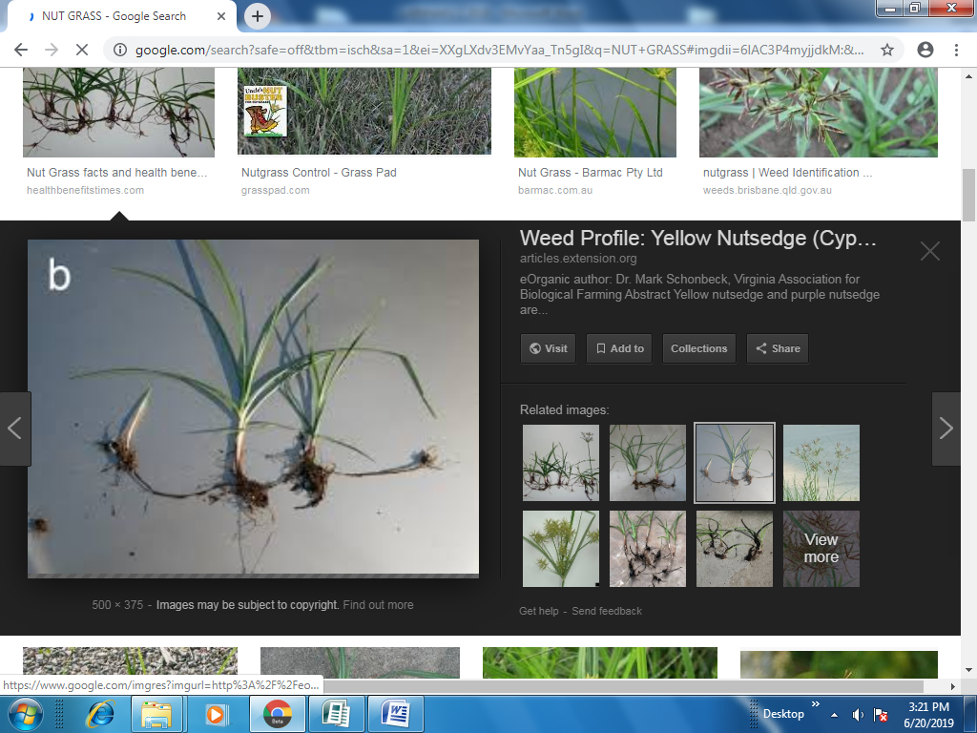 D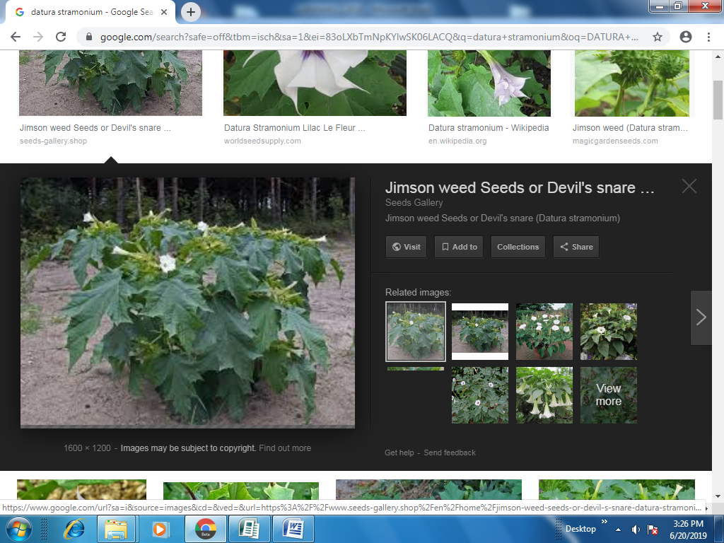

    - Identify the weeds (2 marks)
………………………………………………………………………………………………………
………………………………………………………………………………………………………
………………………………………………………………………………………………………
………………………………………………………………………………………………………

    - State one major disadvantage of weed labeled A (1 mark)
………………………………………………………………………………………………………
………………………………………………………………………………………………………

    - Give two reasons why weed C is difficult to control. (1 mark)
………………………………………………………………………………………………………
………………………………………………………………………………………………………
………………………………………………………………………………………………………

    - State one economic importance of the weed labeled (B) to human beings (1 mark)
………………………………………………………………………………………………………
………………………………………………………………………………………………………

- The table below shows weekly demand for rice in am market
Price (ksh) Quantity demanded (kgs)
10 250
9 350
8 550
7 600
6 700
5 1000
4 1500
a) Calculate the elasticity of demand (Ed) for rice when the price falls from Kshs. 10 to Kshs. 9 per Kg. (show your working) (3 marks)
………………………………………………………………………………………………………
………………………………………………………………………………………………………
………………………………………………………………………………………………………
………………………………………………………………………………………………………
………………………………………………………………………………………………………
………………………………………………………………………………………………………
………………………………………………………………………………………………………
………………………………………………………………………………………………………
b) Other than price state any other factor that may factor that may increase the demand for rice in the market (2 marks)
………………………………………………………………………………………………………
………………………………………………………………………………………………………
………………………………………………………………………………………………………
………………………………………………………………………………………………………

- The following diagrams shows various samples of soil aggregates
P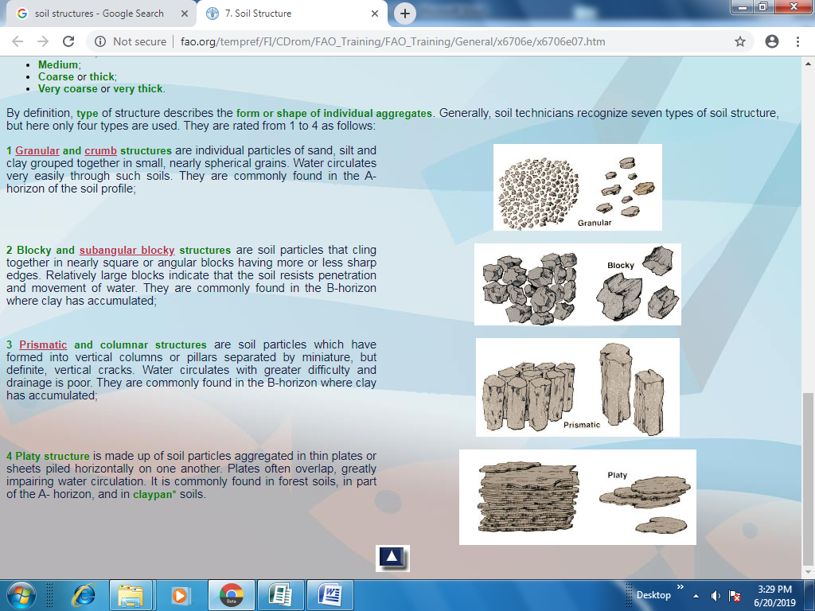 Q 
R  S

  - Identify the type of soils structures (2marks)
………………………………………………………………………………………………………
………………………………………………………………………………………………………
………………………………………………………………………………………………………
………………………………………………………………………………………………………

  - Briefly explain how soil structures P can be improved (1mark)
………………………………………………………………………………………………………
………………………………………………………………………………………………………
………………………………………………………………………………………………………

  - Name two places where soil structure labeled S can be found (2 marks)
………………………………………………………………………………………………………
………………………………………………………………………………………………………
………………………………………………………………………………………………………

- Study the following photographs and use them to answer the question that follows
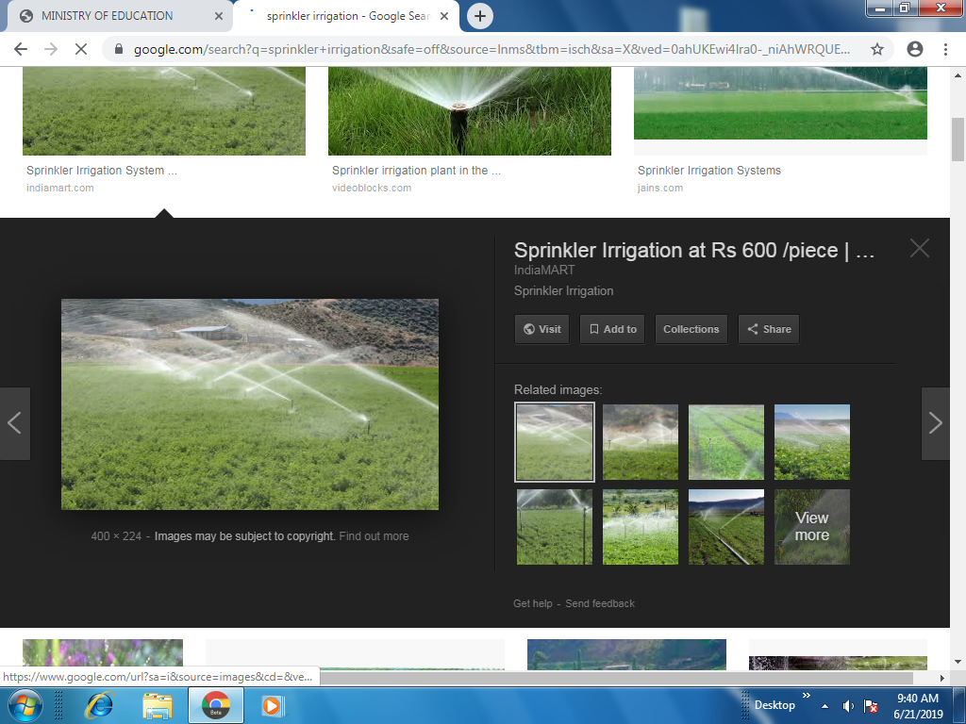
  - Identify the type of irrigation shown in the photograph (1 mark)
………………………………………………………………………………………………………

  - State any two advantages of the above method of irrigation (2 marks)
………………………………………………………………………………………………………
………………………………………………………………………………………………………
………………………………………………………………………………………………………

  - Other than the one shown above identify any other two methods that a farmer can use to irrigate his crops (2 marks)
………………………………………………………………………………………………………
………………………………………………………………………………………………………

SECTION C – 40 MARKS)
Answer any two questions and answer them in the spaces provided after question 26
- a) A farmer has 30 hectares of arable land,20 hectares of which is planted withmaize and 10hectares with grass hay. He wishes to replace 10 hectares of maize with Irish potatoes next year. The fertilizer rate will have to be increased from 2 bags per hectare for maize to 4 bags per hectare for potatoes. As a result of the change extra 40 men days of casual labour per hectare will be necessary at the rate of Kshs.100 per man a day. The average yield per hectare of maize is 35bags and for potatoes 120bags.The price paid is Kshs.1, 000 per bag of maize and Kshs.600 per bag of potatoes. Maize seeds cost Kshs.750 per hectare and potatoes cost Kshs.800 per hectare. Fertilizer costs are Kshs. 650 per hectare.
i) Draw up a partial budget and advice the farmer accordingly. (9 marks)
ii) Name the other type of budget that can be prepared by a farm manager (1 mark)
b) Discuss the various problems associated with land fragmentation (6 marks)
c) Explain four environmental factors that affect the effectives of herbicides (4 marks)

25. a) Discuss the various cultural practices carried by farmers to control pests (10marks)
b) Discuss the production of dry beans under the following headings
          - Varieties (2 marks)
          - Section of planting materials (3 marks)
          - Postharvest practices of dry beans (5 marks)

26 a) Describe harvesting of pyrethrum under the following subheading
i) Method and procedure (3 marks)
ii) Precautions (3 marks)
b) State five characteristics of nitrogenous fertilizers (4marks)
c) Explain five factors to consider when designing a crop rotation programme (10 marks)

